Kendo UI Angular Over Angular material:

Overview of some component in Kendo UI Angular:

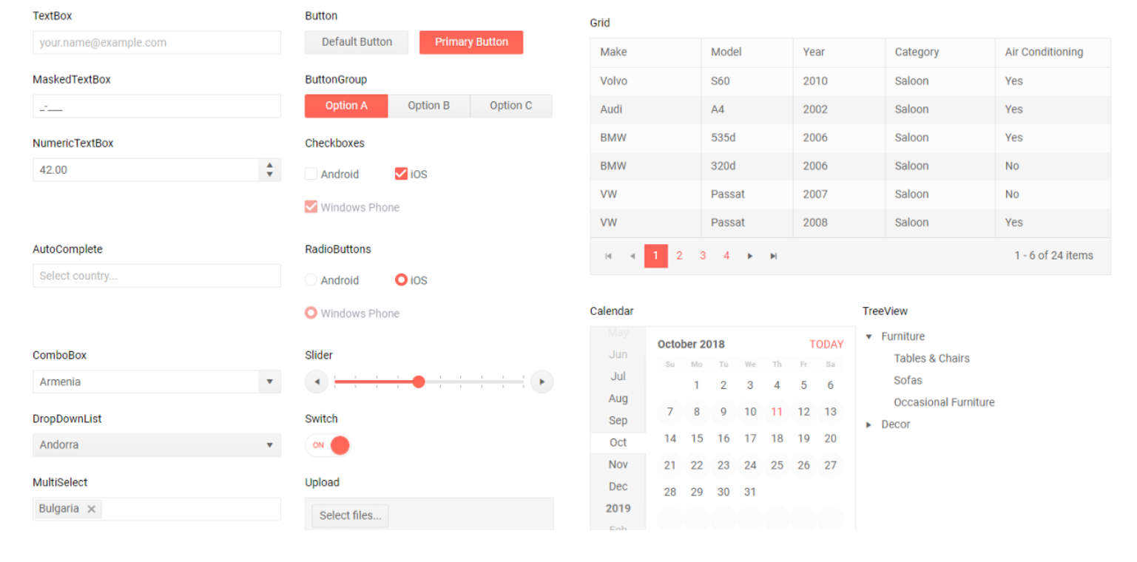

**Pros:**

* Very large set of UI components, including advanced data grid with filtering/search/grouping/stacked columns/sticky columns
* The components provide multiple features out of the box, that allow to easily achieve the desired behavior of any web application. For example the DropDowns module provides four different types of a dropdown, each having its own specific functionality that can be useful for the implementation of a specific scenario
* Good performance for most of the components
* Themes, customizable CSS, ability to easily define your own color palette
* Relatively clean UI
* Good components/API documentation with examples
* Globalization/accessibility features(https://www.telerik.com/kendo-angular-ui/components/grid/globalization/)
* Product roadmap
* Ability to reuse some frontend code if you’re upgrading from JS version
* Advanced support

